**Course code: CSC-284**

**Lab Report: 07**

**Submitted To**

Tanzina Tasnim Bithi

Department of Computer, Science and Engineering

**Submitted By**

Name: Md.Pranto Ali

ID: 23303101

Program: BCSE

Section: A

Semester: Fall 2024

Submission date: Teacher signature

1. **Sum of number using function overloading:**

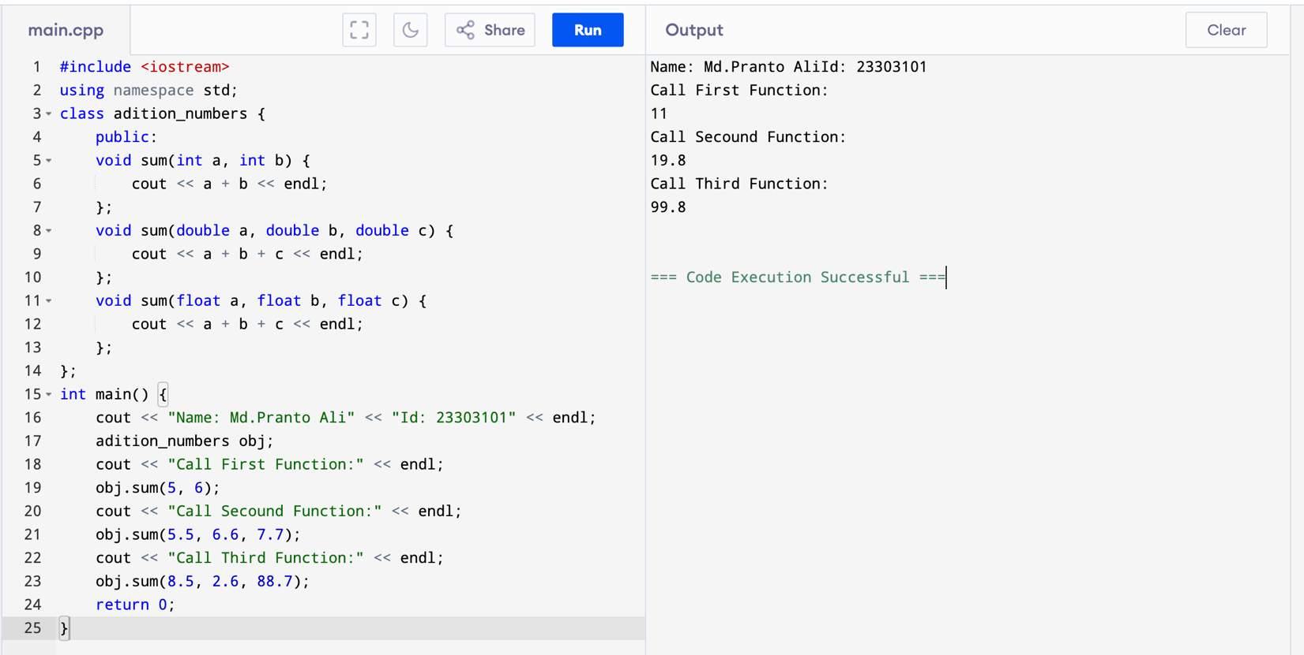

1. **Finding Area of Circle , Rectangle and square Using Polymorphism:**

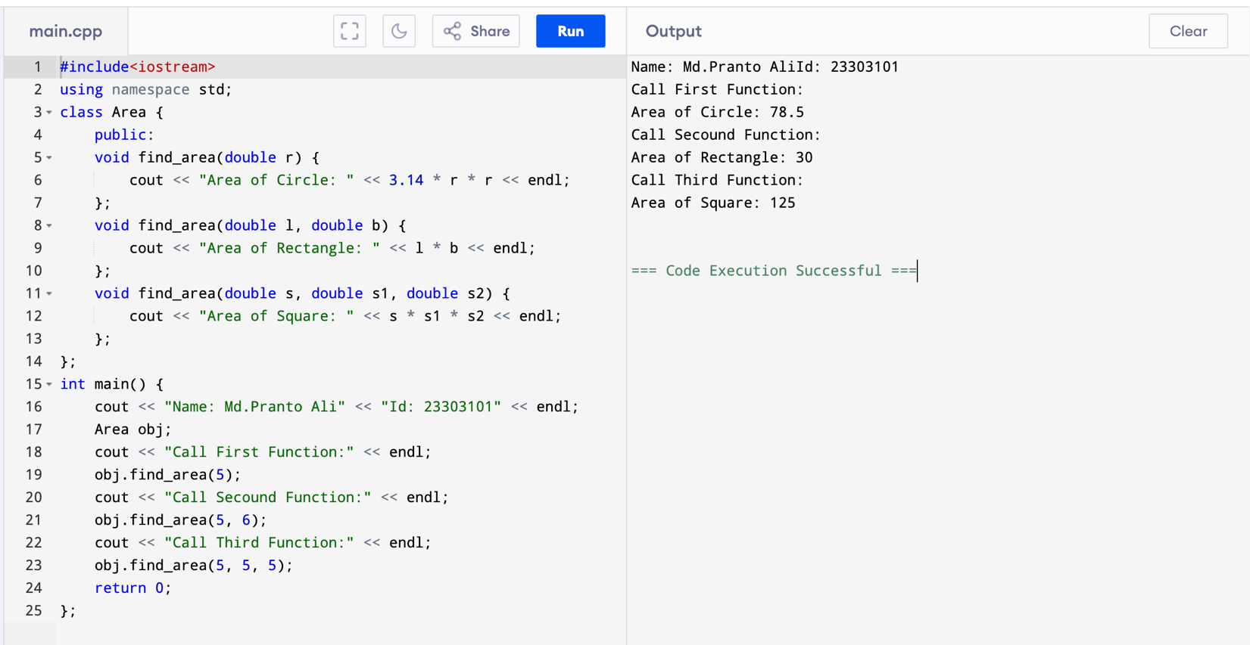

1. **Operator Overloading Unary Minus:**

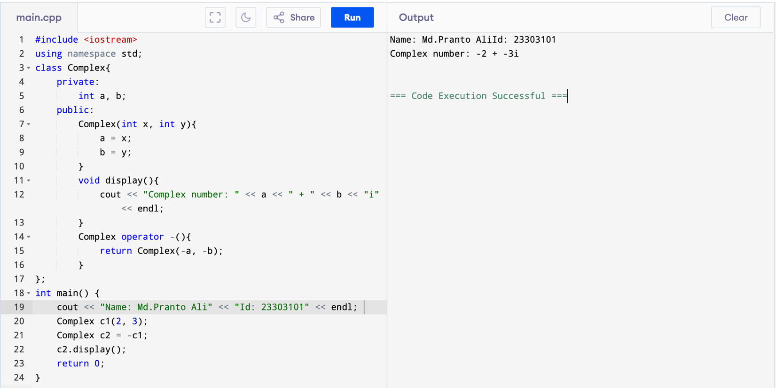

1. **Operator Overloading Increment:**

1. **Operator Overloading Decrement:**

1. **Overloading Binary Operators:**

1. **Overloading Operators addition using Friend:**

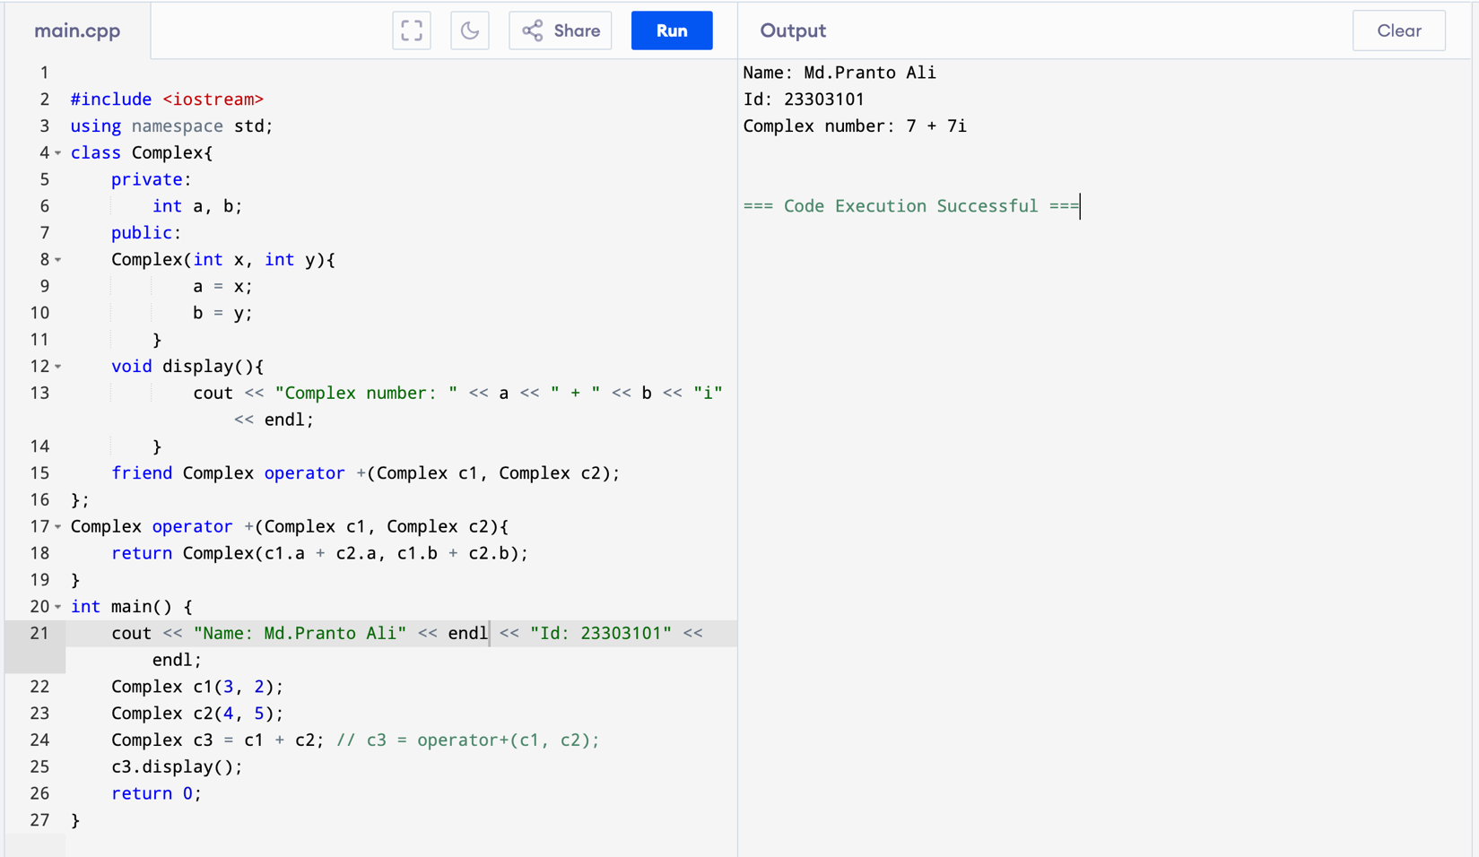

1. **Overloading Operator Using Friend (Add,sub):**

